

|  |  |  |  |  |  |  |  |  |
| --- | --- | --- | --- | --- | --- | --- | --- | --- |
|  | | | | | | | | |
|  | | Lab 2 | Detecting an Intrusion | | | | |  | |
|  |  | | | | | | |  |
|  | | | |  |  | | | |
|  | | | | Cesar Munguia |  | | | |
|  | | | | 10/02/2023—IS-3523-004—Ian Burres |  | | | |
|  | | |  | | |  | | |



|  |  |  |  |  |  |  |  |  |
| --- | --- | --- | --- | --- | --- | --- | --- | --- |
|  |  | | |  |  | | |  |
|  | INSTRUCTIONS | | | | | | |  |
|  |  | | |  |  | | |  |
|  |  | |  | | |  | |  |
|  |  |  | For this lab, you will take on the role of a security operations center (SOC) analyst who  is on duty when an event occurs. You will need to download a custom script onto Kali  that will autoconfigure the attack portion of the lab. You will also need to set up alerts  using Suricata and ensure Wireshark is running before you execute the script. Lastly, you will be able to analyze any information that Suricata forwarded to the SIEM VM using the Splunk web  GUI. | | |  |  |  |
|  | | | | |
|  |  |  |  |
|  |  |

This senior-level cybersecurity course is structured so that all of the four required laboratories we go over make up the steps or actions that an intrusion detection and prevention team would make whenever there is some type of attack or breach against them and their network. Lab 1 was all about analyzing and getting to know the network itself, as well as getting to know the different interfaces that make up the network. To recap a little about the last assignment (lab 1), based on my analysis I found that the following VMs were given a specific IP address: Kali (172.16.2.2), Metasploitable 2 (172.16.2.3), SIEM (172.16.1.3), IPS (172.16.1.4), and Pfsense’s gateway (172.16.2.1). I learned that Kali and Meta2 were in the same network interface (eth0), as well as IPS and SIEM were in the same network interface (enp0s3).

Now based on my previous findings I can now move on into this current assignment. Going back to the “steps” I talked about in the introduction, this particular second “step” is all about detecting an intrusion inside the network. However, there are some things that need to be introduced and talked about before making any special moves. One important aspect about this lab is that now we’re implementing a new virtual machine called Flare VM. This virtual machine doesn’t necessarily interact with the other machines in the network, all it will do in this assignment is inspect the packets sent in the network using Wireshark. The reason we are going to be able to intersect those packets is because Flare VM is in the same network interface (intnet1) as the Metasploitable 2 machine. In addition, we are going to pretend as if Metasploitable 2 is my company’s server and my main objective here will be to only detect if there was in fact a potential breach or intrusion. Finally, just as in the last assignment we are still going to pretend as if Kali was the external user or better known as the attacker/hacker. To have it clear, all Kali is going to do is to execute a bash script that will cause several alerts, logs, etc. to pop up and my mission is to create Suricata the correct alerts, to watch the packets sent in the network by using Wireshark through Flare VM and to inspect several files that could help me come up with my conclusion.

Since my network couldn’t access the internet because it’s a VPN, I had to look for a way to get the script into Kali. For that, in VirtualBox I used Kali’s setting to enable the Drag’n’Drop tool and set it to bidirectional. This way I could easily transfer the script from my computer to the virtual machine. After that, I went to Kali’s terminal and change the permissions of the file to allow execution. Before I even ran the script, I made sure that everything was set and ready for me to begin. I made sure that Flare VM was listening to etho (where Metasploitable 2 was located) in Wireshark, and that all my virtual machines were connected to the network. I went ahead and ran the script by typing ./lab2_encrypted\(1\) in Kali’s command prompt. I wasn’t able to see any output and so I just waited patiently until the script was done executing. The script was done and now it was my time to go detect the potential breach.

The first thing I did is I went ahead and executed the command **arp** in Metasploitable 2 to check who was connected to the VM. Surprisingly, it showed me that there were two connections established. One was for 172.16.2.1 (Pfsense) and the second one was an unknown “external user” with an IP of 172.162.3, both on interface eth0 (refer to screenshot #1). Consequently, this made me curious about what type of connection the external user might’ve established with Metasploitable 2. For that, I had recurred to search in other places around the operating system like netstat and so I checked the network status by typing **netstat -a**. By executing this command, it could hopefully help me have a better idea to see what type of connection the user had done rather than just looking at the ARP table which does not give you that much of a detail. There could’ve been vulnerable ports that would allow the external user to get connected to the network. I executed the command and I started reviewing the output that it gave me. I used Shift +pg up and Shift +up dn to scroll up and down in the output and I noticed that there was some type of TCP connection between the VM and external user with IP 172.16.2.2 (refer to screenshot #2). Local Address was 172.16.2.3:rmiregistry and the Foreign Address was 172.16.2.2:60282 and the state is CLOSE_WAIT. So, I can ask myself this question, what type of valuable information can I get out of this? Well based on the oracle documents in their website, RMI is essentially a remote method invocation, meaning that if one computer needs a service or method it can easily get it remotely from another computer (*Java development kit version 17 API specification*, July 10, 2023). CLOSE_WAIT means that the connection has been established and the remote user has closed the connection and is waiting on the local system to close it too. So, right now I have some information but I don’t have all of it. For that reason, I will go ahead and look at the packets and the type of packets that were being sent during the execution of the script in Kali’s terminal. I looked at my .pcap file in Wireshark and started my analysis. First, I took a look at the ARP packets since it was the first command I used in Meta 2 to confirm that there was a connection established with Kali. By looking at the ARP packets I could tell that 172.16.2.2 sent a broadcast message to look for 172.16.2.1. To recall, 172.16.2.1 is the Pfsense or the default gateway (router), and so the attacker targets this IP address because it knows that 172.16.2.1 knows where 172.16.2.3 is. The following screenshots shows how I came up with this conclusion (refer to screenshot #3). The other thing I notice too is a big number of TCP packets targeting different port numbers (refer to screenshot #4). Those same TCP packets contained an ACK coming from 172.16.2.2. What can this tell me? That the attacker is most than likely trying establish a connection by using nmap to see what available ports are opened and closed and the TCP packets containing an ACK tell me that the hacker established a connection with something (refer to screenshot #5). This is a very common way that attackers begin to look for exploits. After looking at the .pcap file I also noticed that SSH packets were being sent in the network which made me wonder if the attacker might’ve started the SSH service and might’ve tried to focus on a SSH connection. I also notice a lot of HTTP, TSL, and ICMP packets being sent in the network. Now, this gives me a better idea of what the hacker could’ve tried to do during his attack. My best guess right now is that he first tried to use nmap to detect the opened ports so that he could communicate through there and established an TCP connection using port 22.

I felt like looking at the .pcap was a great thing to do in order to understand the attack but I also need to look at other things so that I wouldn’t overwhelm myself by just staring at packets. Therefore, I decided to look at Splunk. The IPS machine and the SIEM (splunk) are closely related to each other, by that I mean that IPS is responsible of overseeing the network and create any type of necessary alerts, logs, etc. The SIEM comes handy because it lets me see everything in a more friendly manner. I could really use the IPS machine to look at the packets but I will decide not to for simplicity reasons. I went ahead and accessed Splunk by navigating into the browser in my host virtual machine (from the cyber range). I signed in and typed “index=main event_type=alert | table alert.signature | dedup alert.signature” in the search box so that I could see the specific alerts that Suricata made. I noticed that there was some type of correlation between the packets I’ve previously seen in my .pcap file and the alerts, they were very similar (refer to screenshot #8 and #9). In fact, the alerts confirmed me that the attacker used nmap to see for open ports and that he sent SSH traffic on non-SSH port (refer to screenshot #6). One particular alert that caught my attention was “ET Policy Possible Kali Linux hostname in DHCP Request Packet”, meaning that the Kali machine was probably requesting something inside the network by pretending to be Meta 2 and that’s why the alert triggered. Alert “… Unauthenticated Remote Command Execution” basically tells me the same thing also. Then I started to notice the shift of the alerts from SSH alerts to Remote-Execution alerts to HTTP alerts (refer to screenshot #7 and #9). For what I’m seeing in the alerts the attacker probably tried to log in into the web server and he was maybe able to crack the password because it was unencrypted. After having access to the web server, he added a message saying “THIS SITE HAS BEEN PAWNED. THE BAD BANDBITS STRIKE AGAIN !!!” (refer to screenshot #10). There was a particular disclosed vulnerability that the Splunk alerted to me and it was CVE-2019-1653 which I believe it somewhat explains this scenario. The cvi.mitre.org website states that “[t]he vulnerability is due to improper access controls for URLs. An attacker could exploit this vulnerability by connecting to an affected device via HTTP or HTTPS and requesting specific URLs. A successful exploit could allow the attacker to download the router configuration or detailed diagnostic information. Cisco has released firmware updates that address this vulnerability.”. After making my analysis I’ve decide to come up with some rules that would apply to this scenario.

I will start by making Suricata rules which I will be explaining every single one of them in the next section. Before I even made any particular Suricata rules I had to make sure that the Suricata configuration file (located at /usr/local/etc/suricata/***suricata.yaml***) was taking in consideration the rules I would add myself and not just its own rules, which are stored in the file called ***suricata.rules***. This particular file adds its own rules whenever there is an update in Suricata but I want to add my own. So, for that I will first need to create a file called local.rules in the Suricata’s rule directory which is /usr/local/var/lib/suricata/rules. For that I used command **sudo touch /usr/local/var/lib/suricata/rules/*local.rules***. Then, for testing purposes I wrote two rules that we went over together in the class, which I will explain later. After writing my rule using vim I exited it by hitting ESC and then **:wq**. Then, I went back to the Suricata’s configuration file, opened it using vim, and inserted “local.rules” under rule-files and under its default suricata.rules file. I exited vim and used command **sudo suricata -T -c /usr/local/etc/suricata/suricata.yaml -v** to test if my IDS configuration was successful, which it was.

Going back to the rules I’ve talked about; I will give a brief explanation into what they mean. First rule generates an alert, with protocol ssh, if any packets are sent from any source with any port to destination “Meta 2” (172.16.2.3) using any port but excluding port 22 (ssh).

Second rule sends an “unreach error” to the sender of the matching packet, with protocol ssh, if any packets sent from source “Meta 2” (172.16.2.3) with port 22 to destination “Meta 2” with port 22. This second rule essentially stops/rejects any connection that is attempted by the attacker using ssh. SSH would allow the user to gain remote access to the “Meta 2” through Kali.

Those rules were made with the help of my professor, however, we were asked to create more rules for Suricata. I’ve come up with some ideas about what kind of rules I should make regarding this. Since I had in mind that many HTTP packets, and TCP packets targeting port 80 were sent through the network I’ve decided to create some rules in Suricate in my local.rules file. The first rule would reject http packets coming from 172.16.2.2 using port 80 to 172.16.2.3 using port 80. This would essentially block any packets coming from Kali as we already know its intentions was to get into our network. The second rule would reject TCP packets coming from 172.16.2.2 using port 80 to 172.16.2.3 using port 80. I’ve decided to use destination and source port 80 because that’s what I mainly saw in the .pcap file. I’ve also decided to use source IP 172.16.2.2 strictly because I knew for a fact that it was the only machine executing malicious activity. Rejecting TCP packets from any IP address with any port would essentially block literally all the packets, which is not a good idea. Finally, I wanted to include a rule that would block TELNET because it’s a vulnerable port just as HTTP. So, my third and last rule reject TCP packets coming from any IP using port 23 to 172.16.2.3 using any port but 23. This would block any incoming non-TELNET traffic in a TELNET port. All these rules would hopefully protect my network better for any future attack (refer to screenshot #11).

##### Screenshots

Screenshot 1

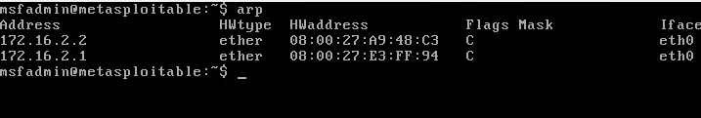



Screenshot 2

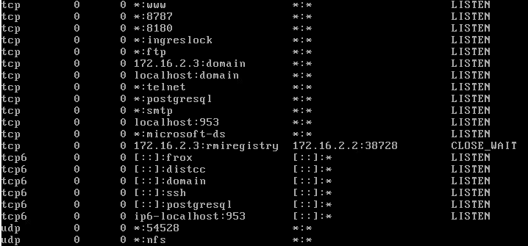



Screenshot 3

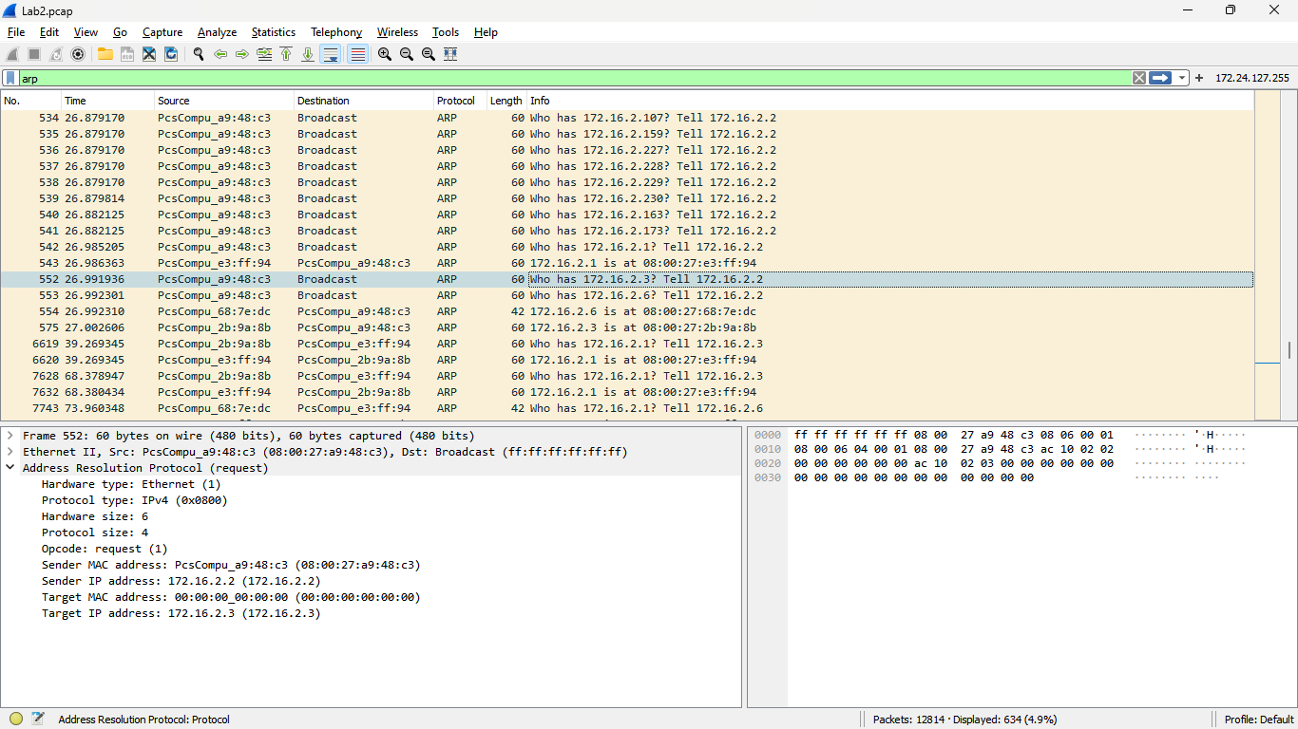



Screenshot 4

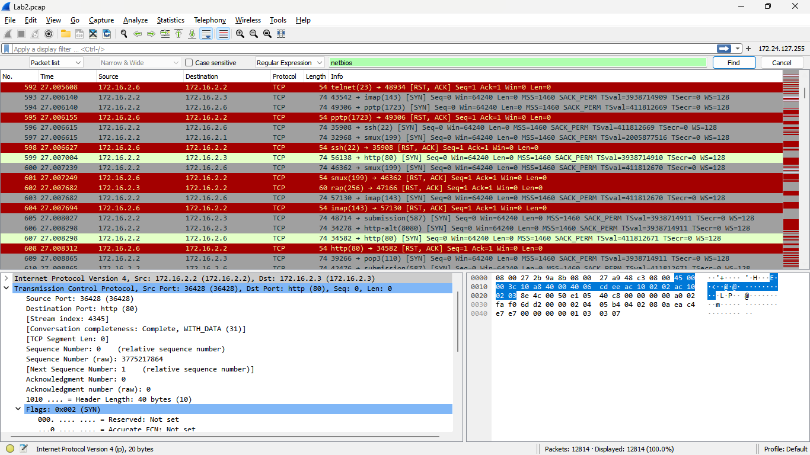



Screenshot 5

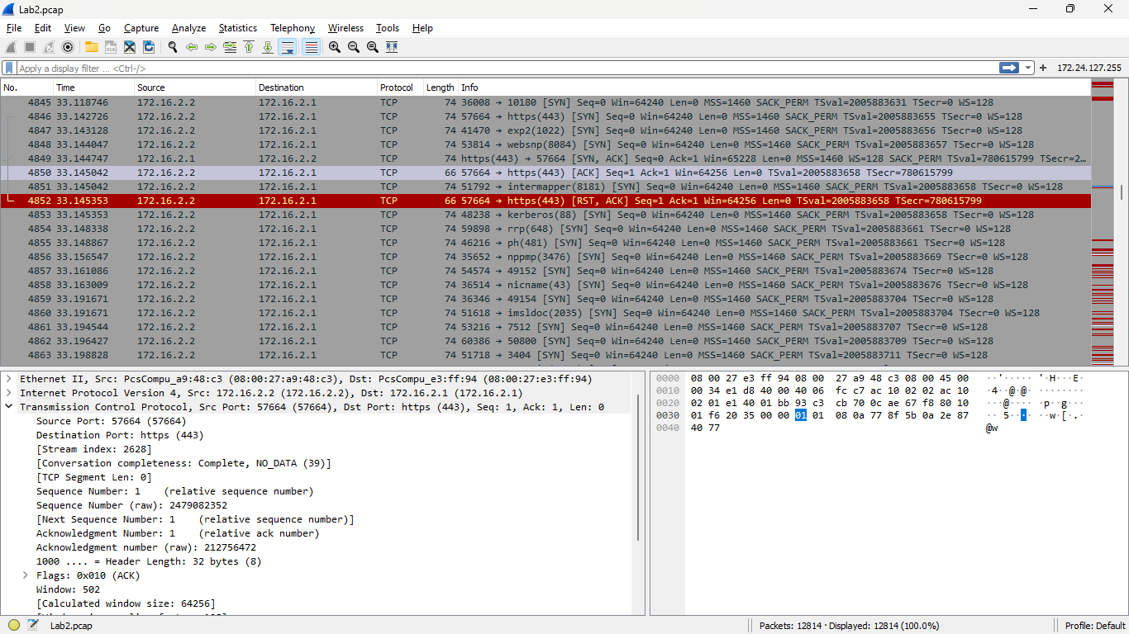



Screenshot 6

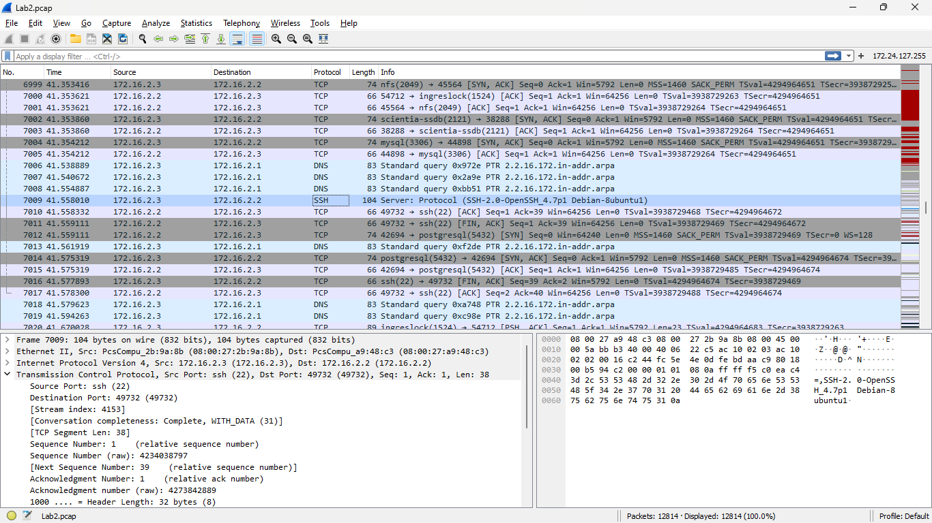

Screenshot 7

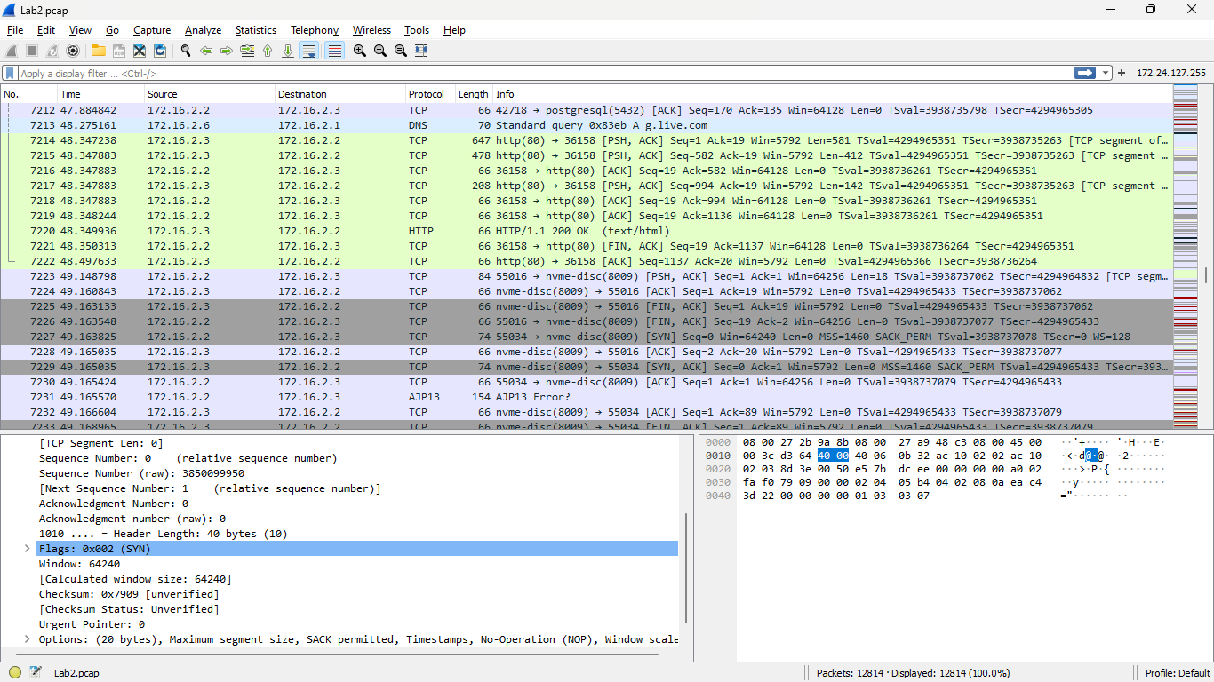

Screenshot 8

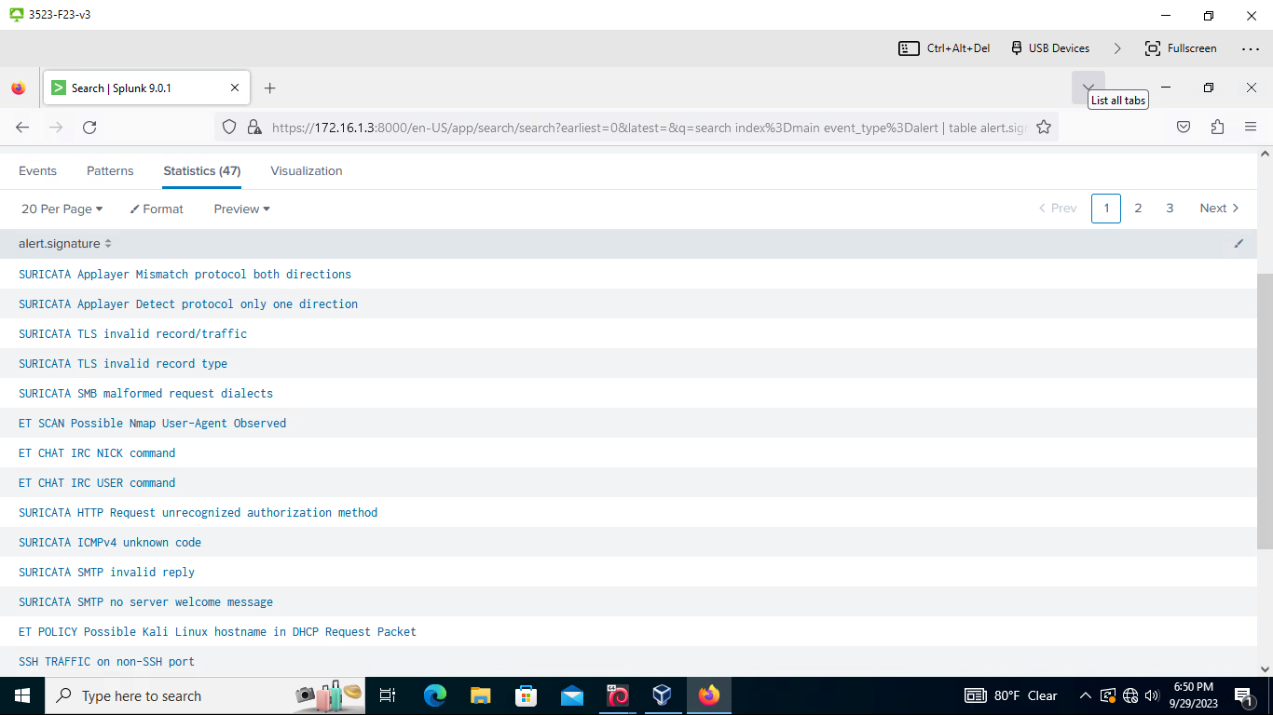



Screenshot 9



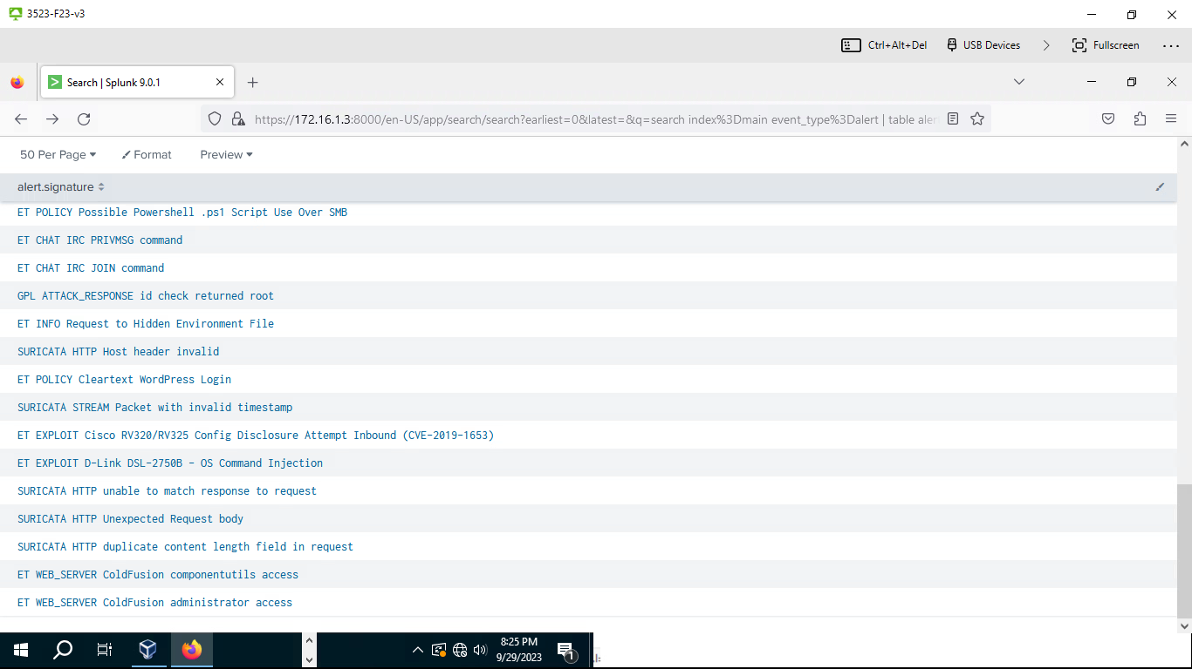



Screenshot 10

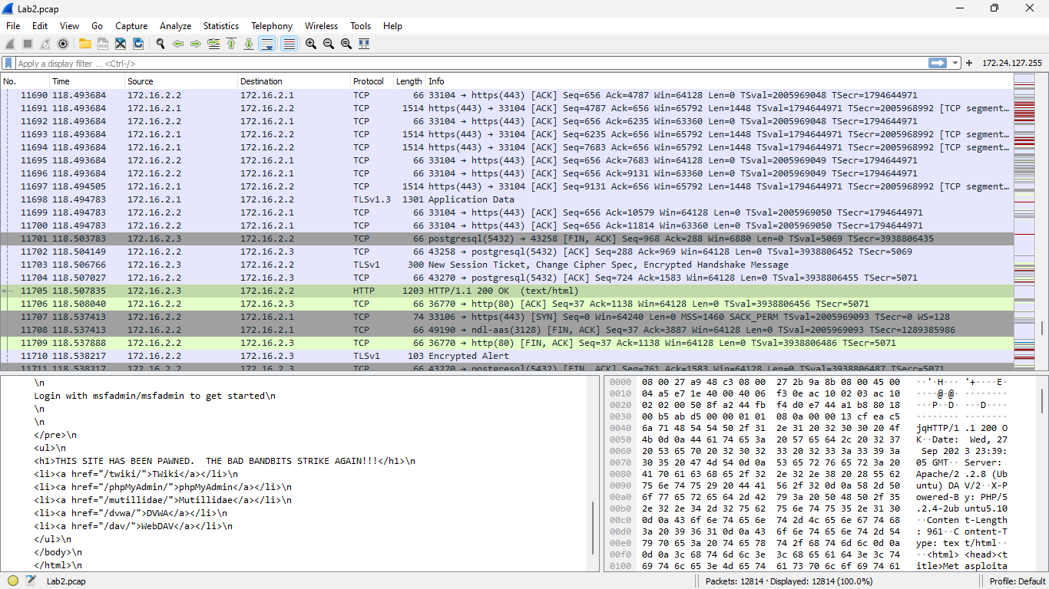



Screenshot 11

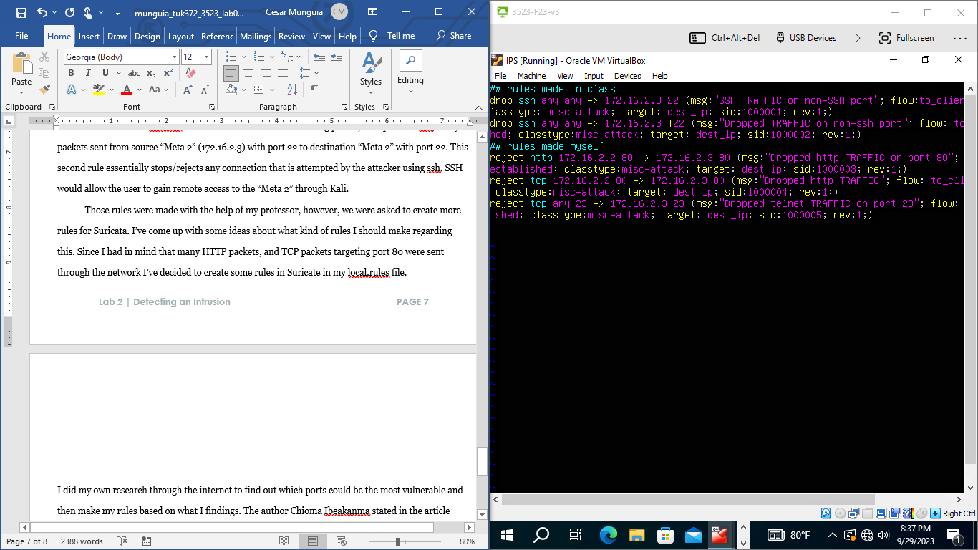



# References

*Java development kit version 17 API specification*. Moved. (2023, July 10). https://docs.oracle.com/en/java/javase/17/docs/specs/man/rmiregistry.html#:~:text=rmiregistry%20%26,and%20make%20remote%20method%20invocations.

NVD. (n.d.). https://nvd.nist.gov/vuln/detail/CVE-2019-1653